**Q.1) Ans- Cutlets Example**

**Anderson Darling Normality Test**

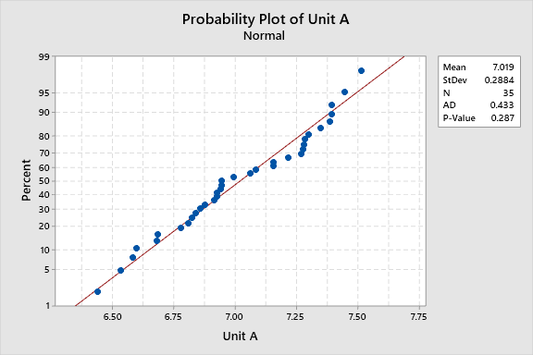

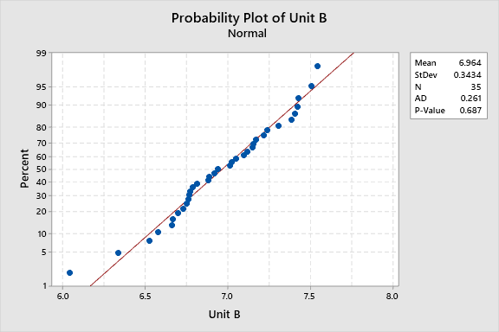

**Unit A P-value 0.287 > 0.05**

**Unit B P-value 0.687 > 0.05**

**Both Unit A and Unit B are normally distributed.**

CUTLETS.CSV

**Test and CI for One Variance: Unit A, Unit B**

**Method**

|  |
| --- |
| σ: standard deviation of Unit A, Unit B |
| The Bonett method is valid for any continuous distribution. |
| The chi-square method is valid only for the normal distribution. |

**Descriptive Statistics**

|  |  |  |  |  |  |
| --- | --- | --- | --- | --- | --- |
| **Variable** | **N** | **StDev** | **Variance** | **95% Lower Bound for σ using Bonett** | **95% Lower Bound for σ using Chi-Square** |
| Unit A | 35 | 0.288 | 0.0832 | 0.252 | 0.241 |
| Unit B | 35 | 0.343 | 0.118 | 0.283 | 0.287 |

**Test**

|  |  |  |  |
| --- | --- | --- | --- |
| Null hypothesis | | H₀: σ = 1 | |
| Alternative hypothesis | | H₁: σ > 1 | |
| **Variable** | **Method** | | **Test Statistic** | | **DF** | **P-Value** |
| Unit A | Bonett | | — | | — | 1.000 |
|  | Chi-Square | | 2.83 | | 34 | 1.000 |
| Unit B | Bonett | | — | | — | 1.000 |
|  | Chi-Square | | 4.01 | | 34 | 1.000 |

CUTLETS.CSV

**Two-Sample T-Test and CI: Unit A, Unit B**

**Method**

|  |
| --- |
| μ₁: mean of Unit A |
| µ₂: mean of Unit B |
| Difference: μ₁ - µ₂ |

*Equal variances are assumed for this analysis.*

**Descriptive Statistics**

|  |  |  |  |  |
| --- | --- | --- | --- | --- |
| **Sample** | **N** | **Mean** | **StDev** | **SE Mean** |
| Unit A | 35 | 7.019 | 0.288 | 0.049 |
| Unit B | 35 | 6.964 | 0.343 | 0.058 |

**Estimation for Difference**

|  |  |  |
| --- | --- | --- |
| **Difference** | **Pooled StDev** | **95% Lower Bound for Difference** |
| 0.0548 | 0.3171 | -0.0716 |

**Test**

|  |  |  |  |  |
| --- | --- | --- | --- | --- |
| Null hypothesis | | | H₀: μ₁ - µ₂ = 0 | |
| Alternative hypothesis | | | H₁: μ₁ - µ₂ > 0 | |
| **T-Value** | **DF** | **P-Value** | |
| 0.72 | 68 | 0.236 | |

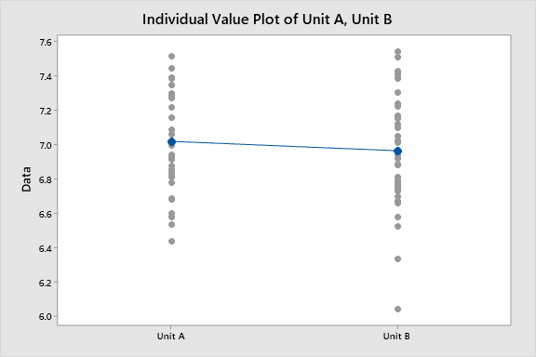

**P value is 0.236 > 0.05 , so accepting Ho and rejecting H1**